2019 STEM Leadership Program
NVU-J Upward Bound
T3 Alliance – Magic of STEM

Instructors: Ryan Bushey, Tony Blueter, and Erica Fuller
Course website: https://t3alliance.org/

Program Description: The T3 alliance summer program provides an introduction to basic computer programing and physical computing within the framework of a growth mindset. Students will be introduced to a variety of programing concepts and given time to explore and develop skills on Raspberry Pi devices. Students will learn about the design thinking process and apply it to various tasks within their community. There will be opportunities to develop communication, problem solving, and teamwork skills. The members of this program will become our STEM Community Leaders during the 2019 UB Summer Program.

Program Objectives:
- Develop a growth mindset
- Build a computer with a Raspberry Pi Device
- Use visual and text based programing languages.
- Understand electrical circuits and sensors with the Raspberry Pi Device
- Communicate with sensors through a network
- Use the design thinking process to address community related issues
- Develop skills for communication and leadership and present to the UB Community at the May 11th Saturday College Meeting
- Become a STEM Leader during the upcoming 2019 UB Summer Program.

General Program Expectations:
- 1. Be present for all scheduled meetings
- 2. Commit to the creation and maintain a UB Full Value Environment for Learning
- 3. You are accepting a leadership role in this program - Commit to the Role of
being an Ambassador of our UB program both within and outside of our community.
- 4. Have fun, challenge yourself, and think outside of the box!
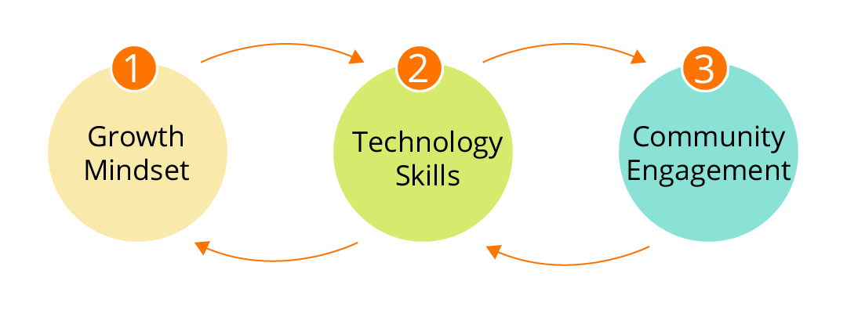
2019 STEM Leadership Program
NVU – J Upward Bound
Class Meetings Date | Location & Times | Class Materials & Assignments
Sunday, February 3  12:00 – 2:30 PM | NVU-J Campus  D 132 | Meeting #1  Parent/Student Meeting – Group Pizza Lunch, Program Overview, Learning Objectives, & Expectations. Growth Mindset and Activity. Orlando Field Experience Paperwork, Q & A Session
Sunday, February, 17  10:00 – 5:00 PM | NVU-J Campus  D 132 | Meeting #2  Build Raspberry Pie Kits, Basic Coding, Community Projects, Project Teams, Roles and Responsibilities  Discussion and Handout Rubric for STEM Presentation at May Saturday Meeting
Sunday, March 17  10:00 – 5:00 PM | NVU-J Campus  D132 | Meeting # 3  More Raspberry Pie Programming and Community Projects  Build Selfie Stations for May 11 Saturday College Meeting  Identify Sensors & Materials List for Summer Projects
Saturday, April 20  10:00 AM | Burlington International Airport | Meeting # 4  Review Goals for STEM Trip, Prepare for Flight, Final Bag Check & Lunch at Airport  Fight to Orlando and travel to hotel for evening
April 21 – 24  STEM Trip | Orlando, FL  Kennedy Space Center  Walt Disney World Resort | (See Detailed Agenda) Handout
Saturday, May 11  9:00 AM – 3:00 PM | NVU-J Campus – Saturday College Meeting | Run Selfie Station Project  STEM Leadership Orlando Fieldtrip Slideshow & Presentation  Launch Summer 2019 STEM Projects
T3 Alliance - Magic of STEM

