DFS SCHOLARSHIP APPLICATION INSTRUCTIONS

How do I apply for a NHS Dollars for Scholars Scholarship? It’s easy… read the instructions below and click on the Student and Parent tab to login and start your application profile today. Final applications are submitted senior year, to be eligible for local and national scholarship opportunities. Continuing education scholarships are available to senior students attending vocational, two-year, and four-year colleges.

Dollars for Scholars applications will be OPEN on November 1st

APPLICATION DEADLINE: The DFS application “submission” final deadline for all NHS senior applicants is MIDNIGHT on February 1. No extensions will be granted. ALL sections of the application form must be complete to be eligible for scholarship consideration.
- Visit http://northridge.dollarsforscholars.org to complete your application.

- Click on the Students & Parents tab at the top of the page. Proceed to the large blue button that says “Click to Login”.
  - First time users- Click on the link directly above the Student Login box to get started.
  - Search for “northridge” and “middlebury” as shown below and click “Choose This School.”
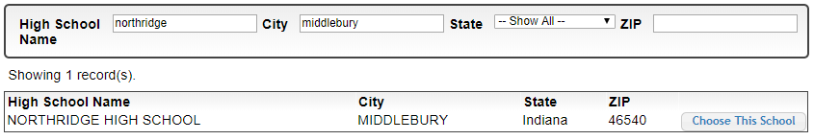

  - Fill out the basic information about yourself and be sure to use an email address you check frequently so you don’t miss alerts about your scholarship(s). After you click Submit, you will receive an email to verify your username and password and be directed back to the “student dashboard”. The dashboard is where you will visit periodically to keep your profile information updated, view progress, link to other national scholarship resources and view scholarship matches.
    - If you are graduating early, you must apply as a senior for the current school year to be eligible for this scholarship.

  - Parents will not be able to login until they receive an email invitation from the student. Click on the link on the right side of the page to login. Parent/Guardian- Please watch your emails to grant consent. Parental consent is required for students age 15 and under.

- To edit your personal profile, click the “Work on Profile” button.
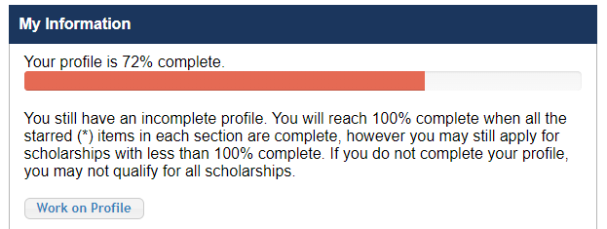

- Complete your free online profile by entering your personal information in each section required. Items with a ** must be completed and items with a single * are part of your dashboard status to show you the percentage of completion in each section.
  - Feel free to fill in other optional info (activities, employment, volunteering, community service, work, test scores, youth groups, sports, etc) in order to be eligible for more national scholarships.
  - GPA: Enter only your current “weighted” cumulative GPA. You do NOT need to enter a 9-12 GPA. Guidance Counselors will verify the GPA after the applications close.
  - DFS Scholarships are merit based and not “need based”. You do not need to complete the financial information to apply for the Northridge DFS Scholarship. However, if you are applying for other national scholarships through Scholarship America, financial information may be requested.

- APPLY FOR SCHOLARSHIPS: After you complete your profile, click on the “Search for Scholarships” button under the blue bar labeled “My Scholarships.”
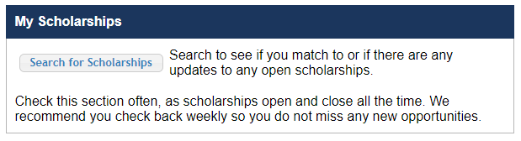
Last year, we awarded over (100) Northridge DFS Scholarships and (1) Norval & Jean Poyser four-year renewable $1,000 scholarship. The Northridge DFS Scholarship will open to view and apply from November 1 to February 1st. To search for other Scholarship America national scholarship opportunities, locate the red bar labeled “Scholarship America Partner Scholarships.” Click on the “Fastweb Scholarships” link to search and apply for any national scholarships outside of our school.

- Essay: Completing the essay is a necessary part of the application: Click the red “Questions” button and answer the 5 questions.
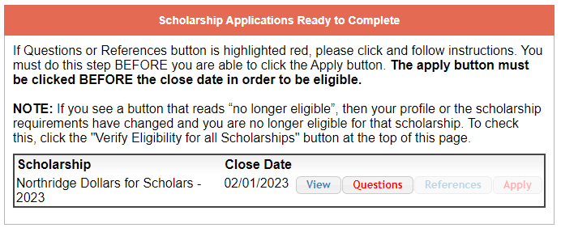
  - The secondary email address is the only way you will be informed about whether you earned a scholarship since the MCS email is disabled after you graduate
  - The last question affects your application score and includes these questions:
    - What are your future goals and why is continuing your education important to you?
    - How will attending college allow you to give back to your community? Include any community service.
    - Unusual circumstances- Please let us know any experience that you feel made a difference in your life, such as; hardship, illness, family issues, etc.
No minimum word length required

- IMPORTANT: Before you submit your completed application, check that all sections are complete. Watch your email Inbox frequently for messages, before and after you submit your application. These emails may go to your Junk folders, so please add dollarsforscholars@scholarshipamerica.org to your “safe sender” list.

- SUBMIT YOUR COMPLETED APPLICATION: Only completed applications will be considered for review. After you have selected and completed the DFS scholarship application (by answering the 5 questions), remember to click “APPLY” to send us your completed application. 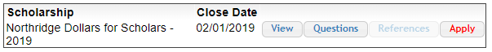
- “ACCEPT” YOUR SCHOLARSHIP: If your DFS application is approved, you will be notified on your dashboard to “ACCEPT” the application. Please remember to click “Accept” under the blue “My Scholarships” bar, prior to July 22, to receive an awarded scholarship. PLEASE NOTE: Only “ACCEPTED” applications received by midnight on 7/22 will be eligible to receive a scholarship.
  - Please note: you must enter a college ID # to accept your scholarship. If you do not know the college you will be attending, or you defer your scholarship for up to one year, please enter zeros for the school and/or student ID, to accept the award.

Scholarship winners will be notified in May if the application is approved. Don’t forget to accept your award. Scholarship Checks will be mailed directly to your college or university on or after August 1.

CONGRATULATIONS AND BEST WISHES!

Northridge Dollars for Scholars
Community Advisory Board of Directors

