**It’s Cold Outside!**

I wish I had an  
IT  
scarf!

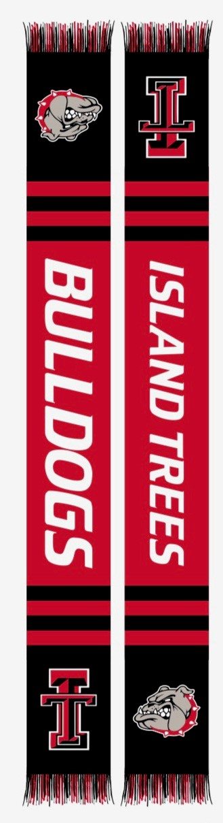

**Island Trees** **Dollars for Scholars**

**Island Trees Winter Scarf**Custom made for Island Trees,  
*warm and cozy* for cold winter days.  
Only $25

All proceeds go directly to   
**Island Trees Dollars for Scholars**,   
which provides scholarships for our   
seniors continuing their education.

**Purchase several ways:**Venmo@dollars4scholarsCash or check payable to Island Trees  
Dollars for Scholars (returned check fee is $20)  
Contact Mia Ortolani at 840-2182 or   
drop your order with name and contact  
info in the Dollars for Scholars   
main office mailbox.   
  
  
**Quantities are limited!**

