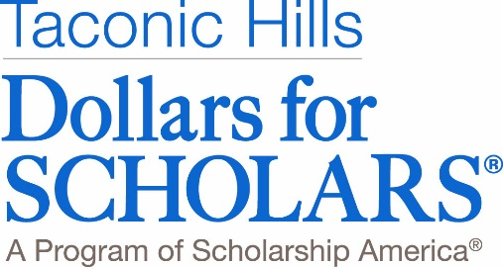

November 2019

Dear Taconic Hills Neighbors and Friends,

Since 1989, Taconic Hills Dollars for Scholars has awarded $1.906 million to 1258 in the Taconic Hills School District. This would not be possible without the generous support of our community. We are a community organization run by volunteers without official school affiliation.

Here is what your donations have meant to our Recipients.

As a first-generation college student, the scholarship sent a strong message that the community supported my future.

DFS is a phenomenal program and has made so many amazing opportunities possible in our community. I am so grateful for the support!

Taconic Hills Dollars for Scholars’ primary objective is to provide scholarship money to graduating seniors who will be attending accredited two or four year colleges or trade schools.

But we also aid underclass members through career exploration as well as non-traditional students; adults returning to college and working towards an undergraduate degree, certification or license to advance in a current job or prepare for another job.

The Taconic Hills community is responsible for the tremendous success of our Dollars for Scholars program. Our annual appeal to the community is one of the major fund-raisers. We again turn to you, on behalf of the students, for your continued generous financial support.

Would you please consider making a one-time donation, establishing an endowed scholarship that can honor a friend or family member or volunteer your time and talent to our organization? An envelope is enclosed for your donation or you may make your donation online at our website. We are a 501(c)3 organization and all donations are tax deductible.

You can find us online at taconichills.dollarsforscholars.org, on Facebook or on Instagram.

Should you have any questions or wish to consider using your talents to join our volunteer DFS Program , please contact us at taconichillsdfs@outlook.com.

We thank you for your support and generosity.

Sincerely,

The Board of Taconic Hills Dollars for Scholars

