Northern Vermont University- Johnson
THE UPWARD BOUND PROGRAM

2018-2019 SUMMER PAPERWORK

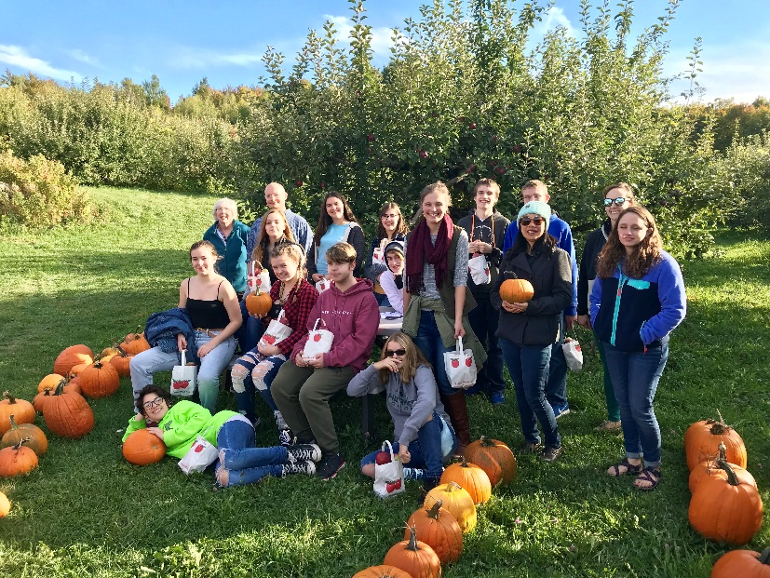

- All paperwork must be submitted by: May 11th, 2019 to be considered for the Summer 2019 Program.

UPWARD BOUND – FORMS CHECK LIST

All forms included in this handbook should be returned to our office by May 11th, 2019. We can only guarantee summer slots to your student if we have all summer paperwork in the office by May 11th, 2019.
If you misplace these forms, we can send you additional copies, or you can download them from our website: www.NVUJUpwardBound.DollarsforScholars.org/summer-forms. Please note some forms have information on the front and back side of the paper; be sure to complete both sides and to SIGN ALL FORMS WHERE INDICATED. Remember, these forms are due in the Upward Bound office by May 11th, 2019.

Returning Student Paperwork:
- Student/Parent Commitment Form (Yellow)
- Full Value Contract (Yellow)
- Big Five Guidelines Agreement (Pink)
- Medical Treatment and Parental Notification Policy (Pink)
- Student Medical History & Physician Release (Neon)
- Medical Consent Form (Blue)
- Responsible Technology Use Agreement (Green)
- Electronic Communications Release (Gold)

Summer 2019 Paperwork:
- Cell Phone Policy & Agreement Form (Yellow)
- Leadership Trip and Off Campus Expectations Contract (Pink)
- Permission to Leave Campus Form (Pink)
- Photography/Digital Media Release Form (Green)
- Summer T-Shirt Size Request (Green)
- Water Bottle Replacement Agreement (Neon)
- Summer 2019 Enrichment Course Interest Form (Neon)

Thank you for agreeing to share your son or daughter with us this summer. If you have any questions before the students arrive on campus for the summer, or anytime while they are with us, please feel free to call the Upward Bound staff. Our normal office hours are 8:00 a.m.- 4:00 p.m.

Location: Contacts:
Northern Vermont University- Johnson Tony Blueter, Director
Upward Bound Office, Senators North Tony.Blueter@northernvermont.edu
337 College Hill
Johnson, VT 05656 Erica Fuller, Assistant Director
(802)635-1267 Erica.Fuller@northernvermont.edu

Northern Vermont University – Johnson Upward Bound
Cell Phone Policy and Agreement Form
Summer 2019
For six weeks each summer, Upward Bound students come to NVU-Johnson for a taste of the college experience, a chance to make new friends, and the opportunity to build new skills both in and out of the classroom. Upward Bound provides free of charge a unique college preparatory learning environment. The goal of the summer program is for students not only to prepare themselves academically for college, but to gain independent living skills and confidence to continue onto college after high school graduation. We strongly believe the foundation of any effective summer program is the successful development of our unique residential campus community. A critical part of establishing our summer community is to provide all community members with learning opportunities to seek out and develop new friendships, explore and discover new talents, which foster a new sense of self-awareness and self-reliance.
The NVU-Johnson UB program has employed a "no cell phone policy" for many years, but we are the first to admit that policy is challenging and sometimes has not been uniformly enforced. In previous experiments with allowing students unlimited use of cell phones we encountered distracted participants who did not fully engaging in their academics and the larger community. This summer we have amended our policy to allow students to bring cell phones to campus. By identifying appropriate times for students to contact family and friends within the summer’s busy schedule, each participant will be given the opportunity to cultivate and balance community expectations and personal independence. Our hope is that by providing students and families with clear guidelines around program expectations critical to the development of our summer community, especially with regard to acceptable cell phone use, will lead to the creation of the best learning environment possible for students’ academic and personal growth.
UB Cell Phone Policy:
- All students will be required to have a completed UB Cell Phone Contract on file with parent signatures.
- NO CELL PHONES WILL BE PERMITTED FOR THE LEADERSHIP TRIP WEEK.
- If a UB student has permission and brings a cell phone to the summer program, it must be kept in their residence hall room and only be used during free time hours throughout the summer program. These hours will vary but are usually scheduled between 4 - 5 PM and 8:00 and 9:30 pm.
  - First violation: Written warning and loss of phone privileges for rest of the week;
  - Second Violation: Contact parent, loss of phone privileges for rest of the week;
  - Third Violation: Contact parent, loss of phone privileges for remainder of the summer;
  - Fourth Violation: Contact parent, student will be dismissed from remainder of summer program.
- In an attempt to assist in the transition back to the UB community on Sunday evenings students are encouraged to not use their cell phone during free time.
- Upward Bound will not be held responsible for any damage or loss of any cell phone voluntarily brought to the summer program. The UB staff reserves the right to update or amend and/or cease this policy at any point in the summer.
Agreement:
Cell Phone Number: ( ) Manufactures Name: Model: Color:

I, ___________________________________________, have read and understand the cell phone policy set forth by the UB Program.
As the parent/guardian, I _________________________________________, ____ Give Permission ____ Do Not Give Permission
(Parent Name)
for my child to, ___________________________________________, to have a cell phone during the 2019 NVU-Johnson UB Summer Program.
(Student Name)

If at any time my child abuses this privilege by not following the Upward Bound guidelines regarding the use of cell phones, I will be contacted and agree to keep my child’s cell phone at home for the duration of the summer program.

________________________________________ ____________________________
(Parent Name) (Date)

Northern Vermont University - Johnson
2019 Summer Leadership Trip
Requirements & Expectations Contract

In order to provide the safest and most engaging trip for all participants, all students need to abide by the following set of program rules and regulations:
I agree to be a full participant in program activities. This includes maintaining a positive attitude, being on time, and keeping an open mind to all scheduled activities.
- I agree to not bring or use any drugs, alcohol, or cigarettes during this experience.
- I agree to not bring or carry any weapons (i.e. pocket knives, mace, or guns etc.) during this experience.
- I agree to not tamper with any fire or safety equipment during this experience.
- I agree to notify the RHD and my Floor Supervisor before this trip of any medication I will need to take while on this trip. This includes the use of a bee sting kit, asthma inhaler, or any other prescription drugs.
- I agree to not enter another student’s room without the permission of the program staff, and not at all between the hours of 10:00 PM and 8:00 AM. I will also be on my floor at the agreed times and in my room, with the lights out by 11:00 PM. These times may be adjusted at the discretion of the program Director or RHD only.
- I understand that male students are not allowed in female students’ rooms at any point during this experience. Likewise, female students are not allowed in male student rooms at any time throughout the duration of this trip. Furthermore, I agree to not engage in any inappropriate sexual conduct of any kind during this trip.
- I understand and agree to support the UB NO STUDENT CELL PHONE POLICY on this trip. Parents may contact the Program Director at any time or call the UB Office if an emergency situation exists and you must contact your son/daughter. Students will be allowed to use a staff phone if needed to contact parents when time permits. Students are encouraged to purchase or bring a calling card and may use phones in the hotel.
- I agree to adhere to all of the hotel rules and regulations. Specifically:
  - Respect the property of the hotel, keep rooms and bathrooms clean. I will not take any property belonging to the hotel (i.e. towels, glasses, remote etc.)
  - I will not order room service, movies/games, pay-tv channels, or use the phone without the permission of the RHD or program Director. I understand everyone in my room will be responsible for any additional charges billed to the room (this includes damage to the furniture and room).
  - Stay off the fire escapes except during an emergency situation in the building.
  - Keep your room windows closed when you are not in your room.
  - I will not prop open my door at any time and conduct myself in a responsible manner while moving around the hotel in order to not disturb other hotel guest.

To ensure the safety and well-being of everyone in the group I also agree to:
- Stay with my group at all times, except with the permission of the RHD or program Director.
- Not carry a lot of money with me.
- Dress appropriately for the day’s activities including footwear.
- Treat everyone with respect, including myself.

I understand that anyone who violates these rules and regulations may be sent home, at HIS/HER OWN EXPENSE, at the discretion of the program Director. If I am sent home I understand this will place my continued participation with the UB program in jeopardy.
_____________________ ______________________
Student Date Parent/Guardian Date

NORTHERN VERMONT UNIVERSITY – JOHNSON
SUMMER 2019 UPWARD BOUND PROGRAM
PERMISSION TO LEAVE CAMPUS
Parents/legal guardians are the only authorized individuals allowed to pick up students during the week (please refer to attendance policy). However, we do understand that not all students ride the bus and therefore some parents/guardians may need to authorize another individual to pick up a student on Friday afternoon to transport them home for the weekend.
Please list those individuals who have permission to pick up your son/daughter on Friday afternoons while they are participating in the Upward Bound program, INCLUDING any students with whom your son/daughter has permission to ride home with.
Student Name: _______________________________________________________
Custodial Parent / Guardian 1 __________________________ / __________________________
Name Phone

Custodial Parent / Guardian 2 __________________________ / __________________________
Name Phone
My son/daughter has permission to leave campus with the following people:

Name/Relationship to Student | Phone Number
Example: Joe Smith (Uncle) | 123-456-7891

My son/daughter MAY NOT leave campus with the following individuals:
____________________________________________________________________________________________________________________________________

__________________________________ ________________________
Parent Signature Date

Northern Vermont University – Johnson

Upward Bound Program
Photo/Digital Media Release Form

This letter confirms the agreement between you and Northern Vermont University-Johnson Upward Bound Program regarding your participation in approved Upward Bound activities in which your child may be photographed or videotaped (the Property) from time to time.

In signing this document, you hereby irreversibly grant to the NVU-Johnson Upward Bound Program continuously, entirely, the right to use and incorporate (alone or together with other materials), in whole or in part, photographs or video footage (including print, non-theatrical, home video, CD-ROM, internet and any other electronic medium presently in existence or invented in the future) taken of your child as a result of their participation in approved activities of the Upward Bound Program.

You hereby agree that you will not bring or consent to others bringing claim or action against the NVU-Johnson Upward Bound Program on the grounds that anything contained in the Property, or in the advertising and publicity used in connection herewith, is slanderous, reflects adversely on you or your child, violates any other right whatsoever, including, without limitation, rights of privacy and publicity. You hereby release the NVU-Johnson Upward Bound Program, its director, officers and successors from and against any and all claims, demands, actions, causes of actions, suits, costs, expenses, liabilities, and damages whatsoever that you or your child may hereafter have against the Johnson State College Upward Bound Program in connection with the Property.

This agreement shall not require the NVU-Johnson Upward Bound Program to use the Property or to use any of the rights granted hereunder, or to prepare, produce, exhibit, distribute or exploit the Property.

The NVU-Johnson Upward Bound Program shall have the right to assign its rights hereunder, without your consent, in whole or in part, to any person, firm or corporation.

AGREED TO AND ACCEPTED on Date:

Participant’s Name (PRINT)

Signature of Participant Date

Parent or Guardian Name (PRINT)

Signature of Parent or Guardian Date

Northern Vermont University-Johnson Upward Bound
Summer 2019 T-Shirt Request

Student Name: _________________________________________________________

Please check your t-shirt size:
____ Small

____ Medium

____ Large

____ X Large

____ 2 XL

____ 3 XL

____ 4 XL

Upward Bound
Northern Vermont University-Johnson
Water Bottle & Replacement Agreement
Each year Upward Bound provides a water bottle to each student and staff member. We encourage students to stay hydrated, and drink the recommended amount of water, which is eight 8-ounce glasses each day. Upward Bound carries out a busy schedule, and students are constantly active on tours, during recreation time, and during other Upward Bound events and trips. After each student has received a water bottle they are responsible to keep possession of his/her water bottle. In addition, we discourage the sharing of water bottles between students in an effort to keep everyone healthy and safe.

By signing below, I agree that Upward Bound provided me (or my son/daughter) with a 32 oz. Nalgene water bottle.

Student Signature:
Parent Signature:

In addition, I, agree that if I lose my Nalgene water bottle I will be responsible for replacing it with a water bottle of my own, or if I choose, I may replace my Nalgene through Upward Bound for a new one at the cost of $12.00 each.

Student Signature:
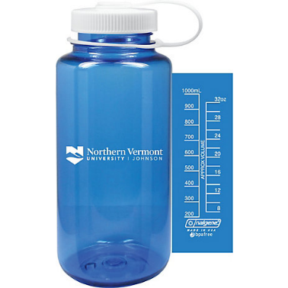
Parent Signature:

