2023 Award Year
Board Members
Jacqueline Rowe
President
Deborah Wolfanger
Vice President
Reggie Ranieri McGuinness Secretary
Penny Wightman Treasurer
Erica Torey
Corresponding Secretary
Carol Baker
Teri Basdekis
Lori Cudney
Pam Ferguson
Andrea Lister
Richard “Otto” Rothermel
Joe Temming
Stephanie Winner

Honorary Board Members
Anne Moriarty
Dolores Noonan

Congratulations on your selection as the recipient of an Oneonta Dollars for Scholars award. The Oneonta Dollars for Scholars Board of Directors is grateful for the community support that enables us to provide scholarship awards to recipients as they embark on their higher education journeys.

The ODS Board understands that circumstances may arise that require you to defer receipt of your award. You may request a deferment for one year at a time for a total deferment of no more than two years (five years for military service). Please complete the form below and return it to us via mail or email attachment at the addresses below. All requests require approval by the Oneonta Dollars for Scholars Board of Directors and are made at their discretion. You will receive notification from the board of directors regarding the status of your request via email. Students granted a deferral MUST contact the board of directors in writing via mail or email to request a reinstatement of their award.

We wish you success in your educational venture.

Sincerely,
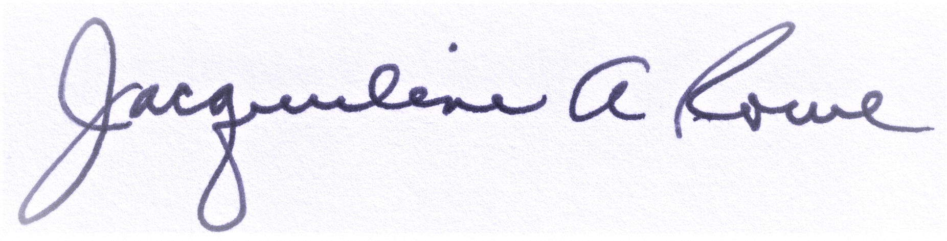
Jacqueline Rowe, President
________________________________________________________________________________

Application for Deferral of Dollars for Scholars Award

Recipient name: __________________________________________________________________

Name of scholarship: ______________________________________________________________

Award year_____________________________Deferral year: __________________________

Reason for deferral: _______________________________________________________________
_______________________________________________________________________________

Student address: __________________________________________________________________

Permanent Email address: __________________________________________________________

Text address/cell number: ___________________________________________________________

