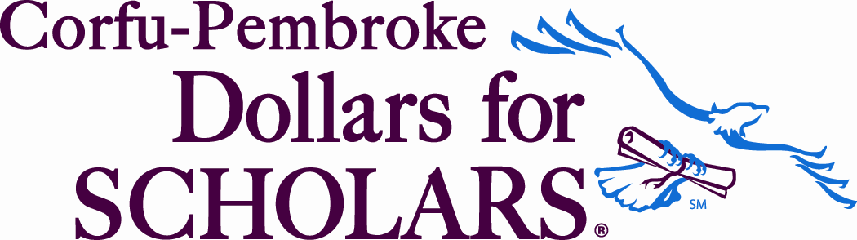
Thought for the day: “Because College Doesn’t Happen by Chance!”
www.corfu-pembroke.dollarsforscholars.org
PEMBROKE DOLLARS FOR SCHOLARS
Meeting –October 09, 2018,
Pembroke Jr. Sr. High School
PO Box 72, Corfu, New York 14036
Present:
Doc (Arthur) Mruczek, Shirley Williamson, Beverly Neeland, Joanna Johnson, Paul Mroz and Jamie Sanner ^{(Late)}
Conflict: Maura Dibble, Toby, and VP Katleen Dethier: Guest: none

Doc Mruczek CALLED THE MEETING TO ORDER at 6:05 pm
Doc Mruczek: reviewed Dragon Tales September 2018, excellent article by Dr. Paul Mroz/Toby
A moment of silence in respect for the Neeland Family
Introduction of Joanna Johnson who will be working with Treasurer Paul
Minutes of October 03, 2017 discussed accepted Shirley Williamson/2nd Joanna Johnson

Paul Mroz -Treasurer
- Treasurer Report: (provided by Dr Paul via email) Reviewed, discussed.
accepted/passed--Doc/2ndJoanna
- Dragon tales will be approached to print four articles each year.
- Motion for Doc to send Scholarship Bill for $4000 to Brad Buyers Scholarships. Motion Joanna/2nd Doc
- Denny's Night Oct 10th- Paul, Joanna, Linda, Shirley, Donna Roads, Art as attendants.
Doc Mruczek -President
- Reviewed Currant Board of Directors roster for national: Discussion (should students be on board?) Motion to accept board members as posted and have Doc verify with National. Shirley Williamson/2ndBeverly Neeland
- Doc met with Dr. Work principle who is pleased w/our work.
- Motion for New Board Member Accept Joanna Johnson as co-worker with Treasurer Paul Mroz passed Doc/Beverly Neeland
- Doc and Donna will donate a "Movie Night Basket" for the Girls Basketball "Pink" fundraiser
- Scholarships: Open 10/1/2017 and close 3/31/2018. Rollover to new school year. Name change by Katleen Tutor Doctor to Buttercrumbs Scholarship with changed description will be done by Katleen after advanced. passed
Katleen Dethier Vice -President
- Winterfest-Corfu Report Katleen wants to thank everyone who helped at Winterfest this year. It was a fun group of people and we all made this event a success. Total deposit was $488.50 gross take, DFS Bank Deposit was $221.50 New this year was the addition of food sales. We sold bakery items and sloppy Joes and did pretty well with that. Since all food related extra items were donated by Buttercrumbs Bakery, we voted to assign the associated sales $267 to the bakery scholarship and the remaining 221.50 to the general operating fund. Thanks again to all for a great event.
- Paul secured $1000 and a gas card for Zak from an anonymous donor for a home schooled student..
New Business
Next Meeting
March 5, 2019 in the Counseling Center to review progress on registration and scholars.
April 23, 2019 in the Counseling Center review and assign scholarship awards
Meetings are open to the Public; contact Corfu-Pembroke DFS information Meetings Start at 6pm, Tuesday Evenings at Guidance Office. Bring a friend to join us.
Motion to adjourn at 7:00pm by Shirley Williamson, second by Bev Neeland, Carried.
Respectfully submitted, Bev Neeland (Maura Dibble-absent)

December, 2018 Addendum: The Chiemlewski Estate delivered a $25,000 unrestricted donation to Corfu-Pembroke DFS. After consulting with Lynne Zervas about protocol and responsibility of accepting the money, a proposal motion was made to divide the check into $20,000 for the scholarship and $5,000 to fund a new account to help make the DFS self sustaining and largely cover the operational account. (proposed Mroz/Second Mruczek)

PROPOSAL TO PARTITION THE CHIEMLEWSKI DFS GIFT
BY
Dr. Paul J. Mroz
Corfu-Pembroke Dollars for Scholars Treasurer
12/30/2018
I propose that the unrestricted Walter B. Chiemlewski gift of $25,000 dollars that DFS recently received be partitioned in the following manner to provide the greatest benefit to the Pembroke students and our DFS chapter:
- Twenty thousand dollars ($20,000) be placed into the Chiemlewski Endowment account to generate capital appreciation (growth) for future scholarship awards. That the 2 annual Chiemlewski awards be increased to $1,000 dollars each beginning with the 2019-2020 awards year.
- That $5,000 dollars be used to start an Operations Endowment account so that the capital appreciation from this account can be used to pay annual operational expenses incurred by our DFS chapter. These monies would greatly reduce the urgency to fundraise for our annual liabilities. That from these funds DFS purchase and own a computer to be used strictly for the following purposes: a.) for financial record keeping including funds investing, monitoring, distributions and communications b.) as a repository for necessary and sensitive documents that the organization must store in accordance with our 501 (C) 3 status (which is considerable) c.) serve as a security vault for our DFS chapter’s financial and email communications with the organization.
Please review and consider these options designed to benefit both the students and our organizational chapter before you vote on this proposal.

To avoid another meeting, the motion was emailed to entire board. A quorum would be (8) and (9) votes were counted by Maura serving as Tellar. After 15 days, 8 yes and 1 abstention were registered. There was no discension but several board members had thoughts about the partician and how the W Chiemlewski Scholarship would change. A fine article appeared in Dragon Tails and another in the Batavia Daily. This will be discussed at the March 5th 2019 Meeting.

