Pre-Trip Workshops

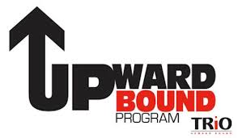

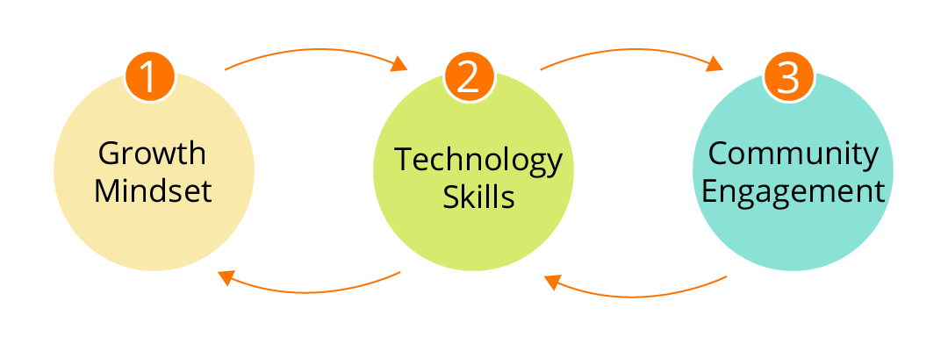

Much of the work for this STEM course will be utilizing the T3 Website, t3alliance.org. This workbook will provide you the structure and chance to reflect while learning about programming with Raspberry Pi. After each exercise, please fill out the engineering journal entries for your future reference.
Please perform the following tasks in order, and have Mr. Bushey, or another instructor, check your work before you move on:
- Wire and Program a Pushbutton, then record in your journal. Check:___________

- Wire and Program a Sonic Sensor, then record in your journal. Check:___________

- Wire and Program a Camera, then record in your journal. Check:___________

  - A reference is provided to assist with this

- Wire and Program a Pushbutton to turn on an LED, then record in your journal. Check:___________
- Wire and Program a PIR to turn on an LED, then record in your journal. Check:___________

- Wire and Program an LED Ring, then record in your journal. Check:___________

- Group Project! Create a Selfie Station!

We will go through the design thinking process together beforehand

References and Extra Materials provided:
- Getting Started with Node Red
- How to Use a Breadboard
- Programming Minecraft with Python – Intro (if you want to learn more about programming!)
- Programming Minecraft with Python – Cannon

Schedule
Class Meetings Date | Location & Times | Class Materials & Assignments
Sunday, February 3  12:00 – 2:30 PM | NVU-J Campus  D 132 | Meeting #1  Parent/Student Meeting – Group Pizza Lunch, Program Overview, Learning Objectives, & Expectations. Growth Mindset and Activity. Orlando Field Experience Paperwork, Q & A Session
Sunday, February, 17  10:00 – 5:00 PM | NVU-J Campus  D 132 | Meeting #2  Build Raspberry Pi Kits, Basic Coding, Community Projects, Project Teams, Roles and Responsibilities  Discussion and Handout Rubric for STEM Presentation at May Saturday Meeting
Sunday, March 17  10:00 – 5:00 PM | NVU-J Campus  D132 | Meeting # 3  More Raspberry Pi Programming and Community Projects  Build Selfie Stations for May 11 Saturday College Meeting  Identify Sensors & Materials List for Summer Projects
Saturday, April 20  10:00 AM | Burlington International Airport | Meeting # 4  Review Goals for STEM Trip, Prepare for Flight, Final Bag Check & Lunch at Airport  Fight to Orlando and travel to hotel for evening
April 21 – 24  STEM Trip | Orlando, FL  Kennedy Space Center  Walt Disney World Resort | Refer to schedule provided at Meeting #1
Saturday, May 11  9:00 AM – 3:00 PM | NVU-J Campus – Saturday College Meeting | Run Selfie Station Project  STEM Leadership Orlando Fieldtrip Slideshow & Presentation  Launch Summer 2019 STEM Projects
Meeting #2 Agenda 2/17/19
- Welcome back! – Rope activity

- Basic Coding with Node Red – follow along with Bushey and progress through tasks

- Design Process introduction and activity

- Continue Basic Coding with Node Red

- Community Projects, Project Teams, Roles and Responsibilities

- Discussion and Handout Rubric for STEM Presentation at May Saturday Meeting

Meeting # 3 Agenda 3/17/19
- Welcome back!

- Finish Raspberry Pi Programming if needed

- Community Projects – brainstorming and/or choices

- Build Selfie Stations for May 11 Saturday College Meeting

- Identify Sensors & Materials List for Summer Projects

