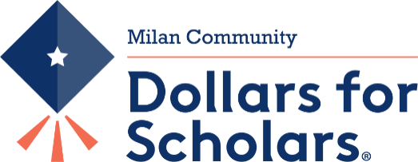
P.O. Box 504
Milan, Indiana 47031

2022 Golf Tournament

Saturday, August 20th 8:00 A.M.

Business Name: __________________________________ Phone # ________________

Contact Name: ___________________________________ Phone # ________________

Business Address: _________________________________
_________________________________
_________________________________

Contribution: ____________________________________________________________
*Donation of $50.00 or more to be Hole Sponsor

Hole Sponsor Info:

*Please make checks payable to:
Milan Community Dollars for Scholars
P.O. Box 504
Milan, Indiana 47031

