May 28, 2014

To Whom It May Concern:

This letter verifies that Temecula Dollars for Scholars, located in Temecula, California, is an affiliate member in good standing of Scholarship America®, the parent company of Dollars for Scholars®. Through its affiliation with Scholarship America, Temecula Dollars for Scholars is a tax-exempt charitable organization under IRS ruling 501(c)(3) and is a publicly supported charity under IRS ruling 170(b)(1)(A)(vi).

Temecula Dollars for Scholars became an affiliate of Scholarship America on July 21, 1987. Temecula Dollars for Scholars’s Employer Identification Number is 46-4604647. Scholarship America includes Temecula Dollars for Scholars on its Group Exemption Roster filed annually with the IRS.

Temecula Dollars for Scholars is an affiliate chapter and has been given their exempt status based upon an IRS ruling given to Scholarship America. Please accept this letter, plus the enclosed supporting documentation on the national organization, as proof of this chapter’s 501(c)(3) status.

Sincerely,
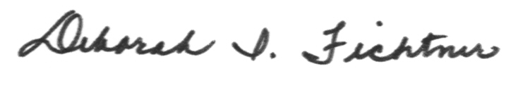

Deborah I. Fichtner
National Director of Operations
Scholarship America Dollars for Scholars®

