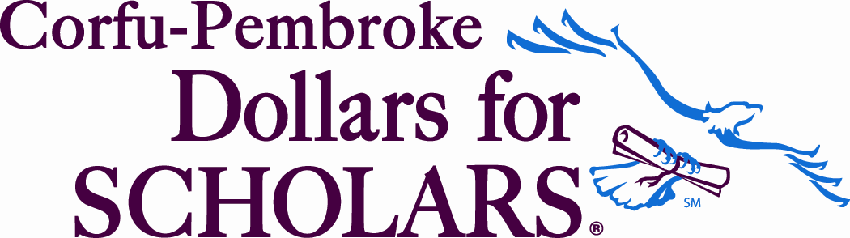
Thought for the day: “Because College Doesn’t Happen by Chance!”
www.corfu-pembroke.dollarsforscholars.org
PEMBROKE DOLLARS FOR SCHOLARS
Meeting –March 06, 2018,
Pembroke Jr. Sr. High School
PO Box 72, Corfu, New York 14036
Present:
Doc (Arthur) Mruczek, Shirley Williamson, Beverly Neeland, Joanna Johnson, and Jamie Sanner ^{(Late)}
Conflict: Maura Dibble, Toby, Paul Mroz Treas and VP Katleen Dethier: Guest: none

Doc Mruczek CALLED THE MEETING TO ORDER at 6:05 pm
Doc Mruczek: reviewed Dragon Tales September 2018, excellent article by Dr. Paul Mroz/Toby
A moment of silence in respect for the Neeland Family
Introduction of Joanna Johnson who will be working with Treasurer Paul
Minutes of October 03, 2017 discussed accepted Shirley Williamson/2nd Doc

Paul Mroz -Treasurer
- Treasurer Report: (provided by Dr Paul via email) Reviewed, discussed.
accepted/passed--Doc/2ndJoanna
- Motion for Doc to send Scholarship Bill for $4000 to Brad Buyers Scholarships. Motion Joanna/2nd Doc
Doc Mruczek -President
- Reviewed Currant Board of Directors roster for national: Discussion (should students be on board?) Motion to accept board members as posted and have Doc verify with National. Shirley Williamson/2ndBeverly Neeland
- Motion for New Board Member Accept Joanna Johnson as co-worker with Treasurer Paul Mroz passed Doc/Beverly Neeland
- Scholarships: Open 10/1/2017 and close 3/31/2018. Rollover to new school year. Name change by Katleen Tutor Doctor to Buttercrumbs Scholarship with changed description will be done by Katleen after advanced. passed
Katleen Dethier Vice -President
- Winterfest-Corfu Report Katleen wants to thank everyone who helped at Winterfest this year. It was a fun group of people and we all made this event a success. Total deposit was $488.50. New this year was the addition of food sales. We sold bakery items and sloppy joes and did pretty well with that. Since all food related extra items were donated by Buttercrumbs Bakery, we voted to assign the associated sales $267 to the bakery scholarship and the remaining 221.50 to the general operating fund. Thanks again to all for a great event.
New Business
Next Meeting
March 31, 2018 scholarship applications close the review of applications need completion before the April 17th scholarship Assignment Meetings Applicants Review Team for this year is:
Aptitude: Toby Beahan
Goals & Aspirations: Katleen Dethier
Activities: Jamie Sanner
Unusual Circimstances: Maura Dibble
Reference: Beverly Neeland
Work - Computer Generated
The five members of the review team must wait until the scholarship close (March 31, 2018) and then review their assigned student's subject before April 16, 2018 for the next meeting to complete scholarship awards.

April 17, 2018 in the Counseling Center to review and assign scholarship awards
Meetings are open to the Public; contact Corfu-Pembroke DFS information Meetings Start at 6pm, Tuesday Evenings at Guidance Office. Bring a friend to join us.
Motion to adjourn at 7:00pm by Shirley Williamson, second by Joanna Johnson, Carried.
Respectfully submitted, Bev Neeland (Maura Dibble-absent)

