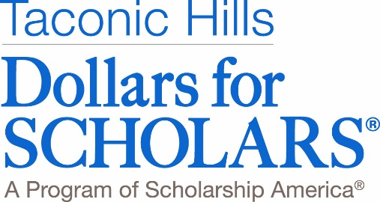

November 2018

Dear Taconic Hills Neighbors and Friends,

Since 1989 Taconic Hills Dollars for Scholars has awarded more than $1,865,000 in scholarships to 1225 students in the Taconic Hills School District. This would not be possible without the generous support of our community.

For many years your donations have made a real difference to students!

As a first-generation college student, the scholarship sent a strong message that the school supported my future. Member of Class of 1997

DFS is a phenomenal program and has made so many amazing opportunities possible in our community. I am so grateful for the support! Member Class of 2014

Taconic Hills Dollars for Scholars’ primary objective is to provide scholarship money to graduating seniors who will be attending accredited two or four year colleges or trade schools. We are a community organization run by volunteers without official school affiliation. Our goal is to deliver and sponsor activities and experiences which will aid our students and adults to prepare for and have access to a post-secondary education.

The Taconic Hills community is responsible for the tremendous success of our Dollars for Scholars program. Our annual appeal to the community is one of the major fund-raisers. We again turn to you, on behalf of the students, for your continued generous financial support.

Would you please consider making a one-time donation, establishing an endowed scholarship that can honor a friend or family member or volunteer your time and talent to our organization? An envelope is enclosed for your donation or you may make your donation online at our website. We are a 501(c)3 organization and all donations are tax deductible.

You may donate or visit us online at taconichills.dollarsforscholars.org.. We are also on Facebook and Instagram where you can see the pictures of the many students that you have helped. Should you have any questions about Dollars for Scholars, please contact us at taconichillsdfs@outlook.com. And please note our new mailing address.

Taconic Hills Dollars for Scholars
PO Box 1119
Philmont, N.Y. 12565

On behalf of the students, we thank you for your generosity and continued support!

The Taconic Hills Dollars for Scholars Board
Ed Herrington Board Chairman Bruce Meyers President P-L Schroeppel Past-President Lynn Hotaling Vice-President
Krista DeRocha Treasurer Tracy Muller Secretary Kathy McNamee Gaye Hoffman Tami Johnston Samantha Maker
Lynn Brandt Wonell Miller Sarah Meyers

