GOOD-BYE 2020!!
WELCOME 2021!!

It’s a new year! 2020 is over! It was a year that no one will ever forget – mostly for the upheaval that occurred! But for your Greencastle Alumni Dollars for Scholars, Inc. there were some accomplishments that made it a year to remember! Even though we haven’t been able to meet as often as we would like—even though we had to cancel our All-Class Reunion Dinner—and even though the Farm to Fork Dinner was changed to a drive-through event—we did have some accomplishments! And we would like to share some of them with you! At the beginning of 2020 our Foundation balance was $427,003.57. At the end of 2020 our Foundation balance was $513,611.05. That is an increase of over $86,000!! We are now a full-fledge member of Scholarship America and Dollars for Scholars. And we have increased our board membership from eight members to eleven. We could NOT have accomplished these without the help of our members and alumni! We THANK YOU! You can continue to help your association and GHS graduates by renewing your membership in the Greencastle Alumni Dollars for Scholars. Just complete the renewal form on page 7 and return it with your dues to us. The membership fee is ten dollars. Or you can contribute $25 to our scholarship fund in memory or honor of someone and your membership is free! Won’t you renew today?
A LITTLE OF
THIS and THAT

New officers for 2021 were approved by your Board. They are President Jon Blue ’69, Vice-President Scott Monnett ’95, Secretary Suzy Gould Schneider ’64, and Treasurer Terri Sutherlin McKee ’74. Terri will remain as Scholarship Chairperson and Ron Blotch will be the Historian.

We are pleased to announce that we have three new board members. They are Todd Detro ’87, Cathy Gram Lowery ’69, and Jane Green Hansen ’69. And it looks like a fourth new member will be approved in the next couple of board meetings. Our ultimate goal is to have between 15 to 20 board members.

Your Board has four goals for 2021: (1) increase membership in the Greencastle Alumni Dollars for Scholars organization. Our goal is to at least double our membership numbers. (2) increase the number of board members to at least fifteen. (3) continue to increase our Foundation balance with a long-term goal of $600,000. And (4) to increase our presence within the Greencastle Community (once the virus allows us to do so).

Although no date has been selected yet, we hope to have the Greencastle All-Class Reunion Dinner this year. A decision concerning the location, date, time, etc. will be forthcoming.

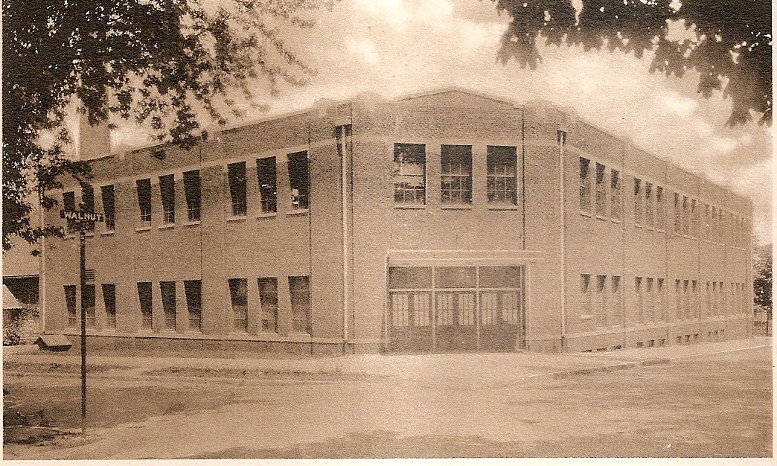

TIGER CUBS IN THE 1990s (1990-91)

As the 1990-91 school year started, the Greencastle Tiger Cubs had aspirations of successful Sectional outings. Although not every team/individual claimed a Sectional Championship, the Tiger Cubs did claim three team and fifteen individual Sectional titles.
Fall Sports
Lori Garner claimed the first Sectional Championship of the school year by winning the cross country title with a time of 16:46. Volleyball was up next, and the Lady Cubs claimed a Sectional Championship by defeating Southmont 15-4, 15-8 and North Putnam 15-11, 15-8. They then won the first match of the Regionals by defeating White River Valley 15-8, 15-8. Their dream of a Regional title ended with a 15-13, 4-15, 15-7 loss to West Vigo. Varsity football won a Sectional Championship by defeating Linton 55-0, Sullivan 28-26 and Monrovia 6-0. The Cubs lost their regional game 40-32 to Evansville Mater Dei.
Winter Sports
Girls swimming added four Sectional Championships to the Tiger Cubs resume. Susan Stark was involved in all four titles! She won the 50 yard freestyle in 25.34 and the 100 yard freestyle in 56.27. Susan was also part of the two relay teams that achieved victory. Susan, L. Condon, B. Haymaker, and K. Nealon won the 200 yard freestyle relay in 1:45.48. The same group of ladies claimed the 400 yard freestyle relay with a winning time of 3:52.11. The wrestling squad claimed five Sectional Championships as Sam Ray (125 lbs.), Damon Carrington (140 lbs.), Wade Berry (152 lbs.), Shane Thomas (160 lbs.), and Rodney Huff (Heavyweight) were victorious.
Spring Sports
Susan Stark carried her winning ways from swimming over to track as she won the 800 meter run Sectional Championship with a winning time of 2:19.7. Not satisfied with a Sectional title she claimed the Regional Championship with a winning effort of 2:16.66. At the state meet Susan gave a valiant effort but fell just short of a State Championship as she finished second – as State Runner-up in the 800 meter run! Lori Garner was Sectional Champ in the 1600 meter run with a time of 5:34. And Joy Tesmer made it a Tiger Cub sweep of the long distance events in the 3200 meter run with a Sectional winning time of 12:15.7. Jason Gibbs claimed two Sectional Championships in boys track by winning the long jump with a leap of 20’9” and the high jump with a height of 6’8”. Baseball wrapped up the Sectional Championships for the 1990-91 school year by defeating Danville 9-1 and South Putnam 6-5 in eight innings. The Cubs were eliminated at the Regionals by dropping a heart-breaker to Sullivan 7-6.
Eighteen Sectional Championships, one Regional Championship, and one State Runner-up made the 1990-91 a very successful year for the Tiger Cubs!

1990

Where were you in 1990? Do you remember 1990? Do you remember that George H. W. Bush was President and Indiana’s own Dan Quayle was Vice-President? Do you remember that Iraq under Saddam Hussein invaded Kuwait and the start of Desert Storm? Do you remember that Germany was reunified? Do you remember that the Baltic states declared their independence from the Soviet Union? Do you remember the movie Ghost starring Patrick Swayze, Demi Moore, and Whoopi Goldberg? Do you remember these prices?
Postage stamp $0.25
Gasoline $1.15
Girl Scout Cookies $2.00
New automobile $16,950.00
New house $123,000.00

A NOTE FROM YOUR PRESIDENT

I have the privilege and opportunity to serve this year as the Greencastle Alumni Dollars for Scholars President. Along with the opportunity to work with Scott Monnett, Vice-President; Suzy Gould Schneider, Secretary; Terri Sutherlin McKee, Treasurer/Scholarship; Ron Blotch, Historian; along with board members Mary Lou Blue, Paul Gould, Dawn York Barger, Todd Detro, Cathy Gram Lowery, and Jane Green Hansen.
I want to extend a special thank you to Ron and Suzy for their tireless efforts and service over the past two years in the role of Co-Presidents. I would also like to thank Terri McKee for her role as Treasurer/Scholarship; she is amazing, truly the glue that holds us together and the catalyst that keeps us moving forward.
On behalf of the Executive Board, I would like to extend an invitation to all those who would like to get more involved in our mission to support Greencastle High School students with scholarships to further their education. You can join as a board member or just help us boost our membership.
We currently have only 199 members out of a possible 5000. I challenge all of you. Sign up one new member. I’ve enrolled all of my kids and grandkids. Help us add to the number of scholarships we give out this year by increasing our membership!
I would like to work with you and invite you to be a new board member.

Give me a call – Jon Blue – 765-721-1539 – Class of 1969

CLASS REUNIONS

Is your class planning a class reunion for 2021? If so, please let us know so we can include it in our next issue of Tiger Tales. As of now we do not know of any class reunion being scheduled. This may be due to the virus, or we have just not been notified. So, if your class is having one, or you know of a class that is, PLEASE contact us. We would greatly appreciate it!

A LITTLE MORE
THIS and THAT

Former Greencastle educator Michael Tzouanakis (GHS class of 1945) passed away this past December. Mr Tzouanakis was a fifth-grade teacher at Jones Elementary for five years. He then served as Principal at Jones for eight years. He became the first Principal at Northeast Elementary in 1964. He retired in 1991. Northeast Elementary is now Tzouanakis Intermediate School. He was involved in Indy Car Racing, working for 30+ years for Patrick Racing and then Rahal, Letterman, Lanigan Racing. RIP Mr. Tzouanakis. You will be sorely missed! Our thoughts and prayers go out to his friends and family.

The 2020 Farm to Fork Drive-Through Dinner sponsored by the Dollars for Scholars/Alumni Associations of Cloverdale, Greencastle, North Putnam, and South Putnam was held this past September. Each organization received $2,200 from the event. The 2021 event will be held in September. It has not been decided what type of dinner (sit-down, drive through, or combination thereof).

The Greencastle Alumni Dollars for Scholars website is almost completed. A couple of snags have developed, but we are confident that it will be “up and running” in a very short time. Plus, we hope to have a website separate from Dollars for Scholars. They both should be finalized within weeks, if not days!

We would like to publicly recognize Garrett Koger from the class of 2004. Garrett tragically lost his life in an accident this past year. But he remembered our association through his life insurance. Garrett is the grandson of former Ridpath Elementary teacher Martha McMains. Our thought and prayers are with his family.

We will be giving out nineteen scholarships this spring to deserving GHS graduates/alumni. Each scholarship is for $1000.

MEET YOUR BOARD MEMBERS
JON BLUE

Jon Blue, president of the Greencastle Alumni Dollars for Scholars is a 1969 graduate of Greencastle High School. After graduation Jon enlisted in the United States Navy where he served his country for four years. Returning home Jon joined the Indiana National Guard and was a member from 1975 through 1979. Jon was employed at Headley Hardware for twenty-nine years. Leaving Headley Hardware Jon worked as Property Manager for Dr. Black. For the last fourteen years Jon has been employed by the Putnam County Housing Authority. He also sells real estate for FC Tucker Advantage Realtors. In his spare time Jon enjoys fishing and playing golf.
Jon has two children–a daughter Heather Elaine and a son Jon David (Buck). His wife Mary Lou has a son Zach. Jon and Mary Lou have eight grandchildren and five great grandchildren. They reside at Heritage Lake near Coatesville.

RON BLOTCH

Ron Blotch is a 1965 graduate of Greencastle High School. After graduation Ron attended Butler University where he graduated in 1970. Ron spent 38½ years in education as a social studies teacher, coach, and athletic director–eight years at Sheridan, 2 years at Southwestern (Shelby), seven years back at Sheridan, and the last 21½ years at Edinburgh. Ron retired in January of 2010. In his spare time Ron enjoys reading, playing bridge, collecting sports memorabilia with an emphasis on sports cards, and attending Colts football games and Butler University basketball games.
Ron and his wife Shannon celebrated their fiftieth wedding anniversary last August. They have two daughters – Stacy Michelle and Caron Rene. They also enjoy spoiling their seven grandchildren. They presently reside in Franklin, Indiana, but hope to move to the Noblesville/Fishers area later this year to be closer to their daughters and grandchildren.

WIZARD OF OZ
1989 MINARET

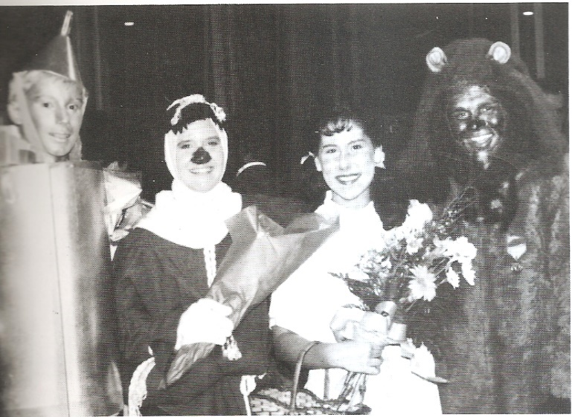
Thespians: Troy Cummings, Katherine Emery, Kim Hinkle, and Jeff Rowe smile after an enjoyable performance of the Wizard of Oz.

FROM IMAGES OF FUNNY CLASS REUNIONS

STATE CHAMPIONS
1925 - Andrew Ray Sears - Mile Run
1926 - Andrew Ray Sears - Mile Run
1927 - Andrew Ray Sears - Half-Mile Run
1927 - Andrew Ray Sears - Mile run
1962 - Steve Norris - High Jump
1981 - Lisa Allen - 800 Meter Run
2005 - Andy Weatherford - 1600 Meter Run
2006 - Andy Weatherford - 1600 Meter Run
2017 - Emma Wilson - 1600 Meter Run
2017 - Emma Wilson - 3200 Meter Run
2017 - Emma Wilson - Cross Country
2018 - Emma Wilson - 3200 Meter Run
2018 - Emma Wilson - Cross Country

GHS ALUMNI MEMORIES

We contacted three GHS Alumni and asked them about their high school memories. Their responses are:

LINDSEY ROWINGS FENWICK

Graduation Year: 2005
Present Address: Greencastle, Indiana
Favorite High School Teachers: Mr. Donavan Wheeler and Mr. Geoff Price
Favorite Middle School Teachers: Mr. Dan Struck and Mr. Geoff Price
Favorite Jones Elementary Teacher: Ms. Liz Spencer and Ms. Julie Carr
Favorite Tzouanakis Elementary Teachers: Mr. Mike Tzouanakis (His enthusiasm was so contagious.) and Mr. Brad Phillips
Favorite High School Class: P.E. minus the
swimming
Favorite High School Memory: One great memory was from my junior year when the basketball team made it all the way to regionals. Cheering during all those games was intense but traveling to Washington, Indiana, late on Friday night after performing as an Indian in the musical Peter Pan. Then the next day cheering on the Tiger Cubs as my brother, Nathan, was in his “G” superman attire with his fellow senior buddies. We were unsuccessful in the game, but what a memory.
Most Embarrassing High School Moment: I can’t think of any I can share. Ha!
What Would You Do Different: I would take my academics more serious. And enjoy the carefree days of high school more.

ERIC TWIGG

Graduation Year: 1989
Present Address: Avon, Indiana
Favorite High School Teacher: Mr. Hile
Favorite Middle School Teacher: Ms. Greenawald
Favorite Elementary Teacher: Mrs. Buckelew
Favorite High School Class: Indiana History
Favorite High School Memory: Going to the Semi-State in basketball and baseball.
Most Embarrassing High School Moment: Not embarrassing but since the statute of limitations is up I was a part of the Great Cafeteria Fork Robbery Gang.
What Would You Do Different: Athletically I would have concentrated on baseball only my senior year.

JIM LEWIS

Graduation Year: 1965
Present Address: Greencastle, Indiana & Loveland, Ohio
Favorite High School Teacher: Ms. O’Hair
Favorite Elementary Teacher: Mr. Dixon
Favorite High School Class: Geometry
Favorite High School Memory: Going to the Senior Prom with Judy Howlett
Most Embarrassing High School Moment: Getting into a hall fight with Ron York and going to the principal’s office where my mother was secretary.
What Would You Do Different: Not be so “clicky”

DID YOU KNOW

That GHS graduate Jane Kelly (class of 1983) is a United States Circuit Judge of the United States Court of Appeals for the Eight Circuit? She was appointed in 2013 by President Barack Obama.

2020 GREENCASTLE ALUMNI DIRECTORS
Jon Blue ’69 (President) 765-721-1539
Scott Monnett ’95 (Vice-President) 352-283-3421
Suzy Gould Schneider ’64 (Secretary) 765-720-2822
Terri Sutherlin McKee ’74 (Treasurer) 765-653-5620
Ron Blotch ’65 317-989-5601
Dawn York Barger ’77 765-247-8222
Mary Lou Blue 630-750-9185 Paul Gould ’58 765-301-9266
Todd Detro ’87 317-281-6508
Jane Green Hansen ’69 765-653-4969
Cathy Gram Lowery ’69 765-721-0150

AN INTERVIEW WITH GCSC SUPERINTENDENT JEFF GIBBONEY

In our last issue of “Tiger Tales” we welcomed Jeff Gibboney to Greencastle as our new Superintendent of Schools. Mr. Gibboney comes to Greencastle after serving as superintendent of schools at Bloomfield. Prior to that he was superintendent at Eminence. He has also been a teacher, coach, athletic director, and principal. He has also served as an outreach coordinator for the Indiana Department of Education. A graduate of South Bend Adams High School, he attended Indiana University graduating in 2005. He has a M.A.E. in Educational Administration and Supervision from Ball State. He completed his Ed.S. in School Administration at Indiana State where he is currently working on his Ph.D.
We asked Jeff some questions about the community and the schools. His responses were:

What was it about the city of Greencastle and the school corporation that attracted you to this position? “I have always been intrigued by the city of Greencastle and long thought GCSC has so much potential to build upon and add to the many great educational programs already in place. I believe Greencastle is a city on the rise with the improvements to the city and additional restaurants and businesses that have been added. I believe there exists greater opportunities for partnerships between local/regional industry, the city, DePauw and GCSC. I believe we have a great family at GCSC, and I look forward to our very bright future.

Now that you have been superintendent for half a school year, what are your impressions of Greencastle and the schools? “My initial thoughts are showing to be true. We have a great city, supportive community partners and an amazing family at GCSC. This has been especially true as we have worked together to navigate the COVID-19 pandemic. Everyone has been so supportive any time we have needed assistance.”

What are two or three short term goals you have for the school corporation? “(1) Learn as much as possible about GCSC and the existing programs we have in place. This will allow me to begin learning about our strengths and also opportunities for growth. (2) Begin to meet our stakeholders and get involved/be visible in our community. (3) Complete a GCSC facilities study in order to begin a 10-15 year masterplan for the district to prioritize renovations and improvements.”

What are two or three long term goals? “(1) Balance the budget and improve the long-term financial outlook for GCSC. (2) Make GCSC the premier district for students within Putnam County and the surrounding area while stabilizing and growing student enrollment. (3) Provide our students, staff and community with modern facilities that are safe/secure, accessible and support educational programming.”

What are some of the strengths of the school system? “We are a family at GCSC and have a team of talented, dedicated and caring staff members. We offer strong programming with a focus on academic achievement and also a variety of co-curricular and extra-curricular activities. We regularly compete or lead the way in both athletics and academic competitions (including our Fine Arts programs).”

We thank Mr. Gibboney for taking the time to share his thoughts and ideas about the community of Greencastle and, what we consider, an outstanding school corporation!

GHS STATE-RUNNER-UPS

1931 - Boys Basketball
1933 - Boys Basketball
1964 - Elliott Williams - High Jump
1991 - Susan Stark - 800 Meter Run
2003 - Charlie Pingleton - Wrestling
2004 - Charlie Pingleton - Wrestling
2006 - Andrew Bretscher - 50 yd. freestyle
2006 - Andrew Bretscher - 100 yd. freestyle
2013 - Colleen Weatherford - 800 Meter Run

Greencastle Alumni Dollars for Scholars, Inc.
formerly known as GHS Alumni Association
Join or Renew Now!
Joining or renewing your Greencastle Alumni Membership will allow you to benefit in a variety of ways...
- You will receive the Tiger Tales newsletter up to 3 times per year
- Receive current news about the association and upcoming events
- Maybe you just want to reminisce or contact former classmates
- Support the awarding of scholarships to GHS graduates

The GHS Alumni Association was created in 1995 for the purpose of supporting Greencastle High School and operating a Scholarship Fund for our graduates. We currently use a number of fundraising events and activities to add to our scholarship fund including the All Class Reunion Dinner, as well as the Dollars for Scholars in Putnam County Farm to Fork Dinner to be held in September 2021.
Membership is only $10 per person per year. To join or renew, complete this application form and mail it to us with your $10 dues payment. Another option is a one-year free membership with a $25 contribution to the Greencastle Alumni Dollars for Scholars, Inc. Scholarship Fund. All contributions may be designated
"In Honor of” _______________ or "In Memory of” _____________________ for anyone that you choose.

Please Print
JOIN RENEW
_______________________________________________________________________________ _____________
Name (include Middle Initial and/or Maiden Name) Class Year
_______________________________________________________________________________ _____________
Name (for use by Couples please include Middle Initial and/or Maiden Name) Class Year
_________________________________________________________________________________________________
Address City State Zip
_____________________________________ _____________________________________________________
Phone Email Address
Receive Tiger Tales via email? Yes _______ No ____________

Total Enclosed $_____________ Mail to. Greencastle Alumni Dollars for Scholars, Inc.
P.O. Box 846
Referred By: __________________ Greencastle, Indiana 46135

- Contribution to Greencastle Alumni Dollars for Scholars, Inc. Scholarship Fund

- In Honor of ___________________________or In Memory of _________________________________

